Confidence interval:

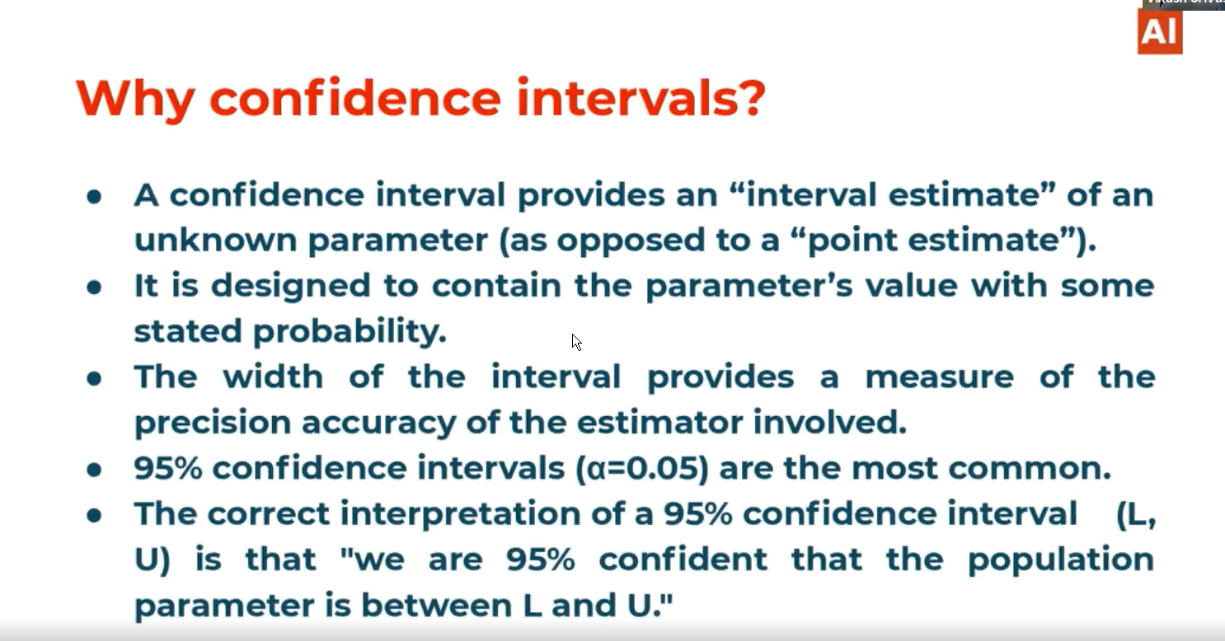

# Point estimation:

Here we say we observed the sample and by the observation we concluded that the population attribute lambda should be 10claims/day.

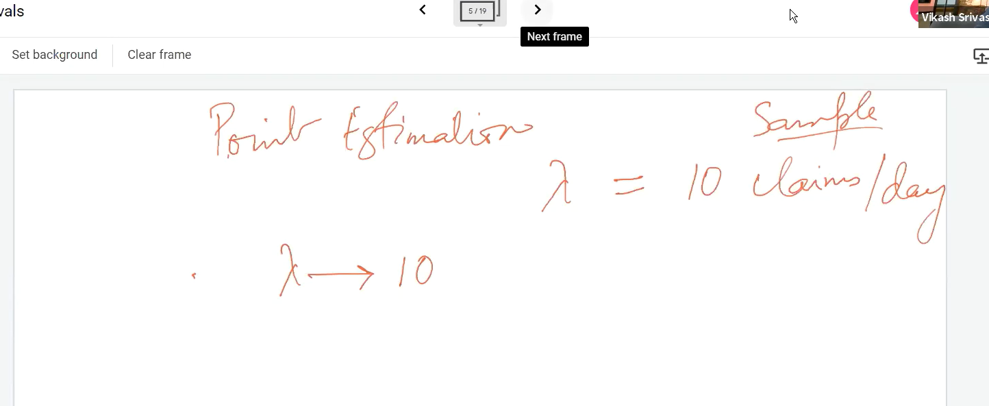

# Interval estimation:

In interval estimation we give one range like in 8-12 the lambda value(Population parameter) lies we had concluded by observing the sample.

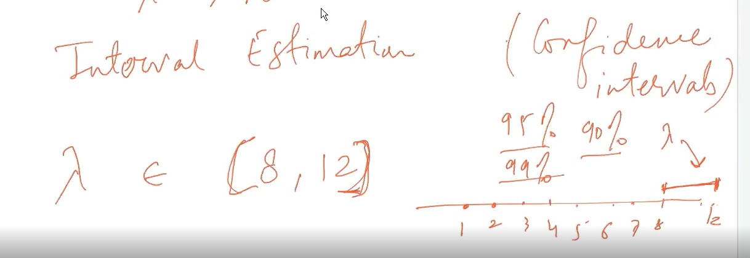

CLT bridge: The CLT is a bridge between your probability theory and statistics. Here by simply analyzing one sample set we can estimate the population/infer the population data no need of analyzing all the sample sets.

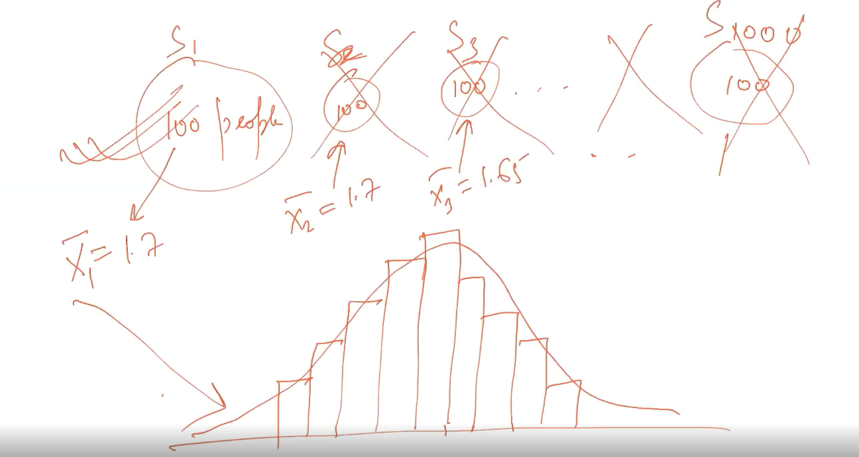

# Confidence interval width is directly proportional to the level of confidence.

# Population parameter:

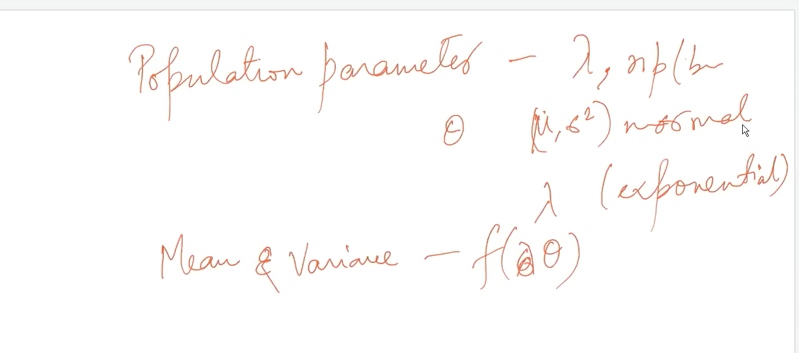

# One sample mean:

